Additional file 6

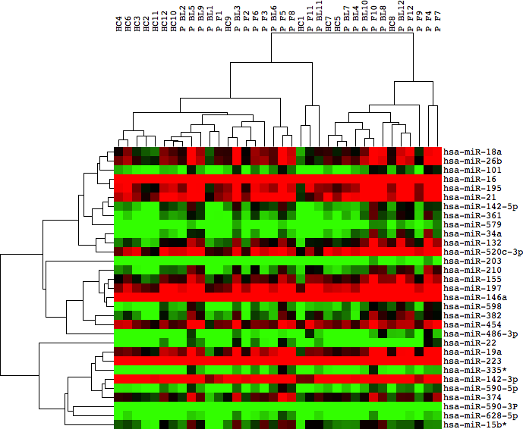

Heatmap for validation phase. For healthy cohort (HC) and progressors baseline (P BL) and follow up samples (P F). MicroRNAs heatmaps were generated using hierarchical clustering (Gene Cluster 3.0 and Java TreeView) Green indicates low expression; Red indicates high expression levels.

