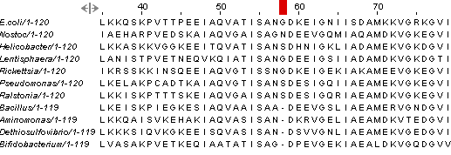

**Additional file 8:** **Figure S8.**