Additional File 3

Trends in mean weekly cigarette sales per adult smoker, by pack size, Scotland and England/Wales, 2011-2015

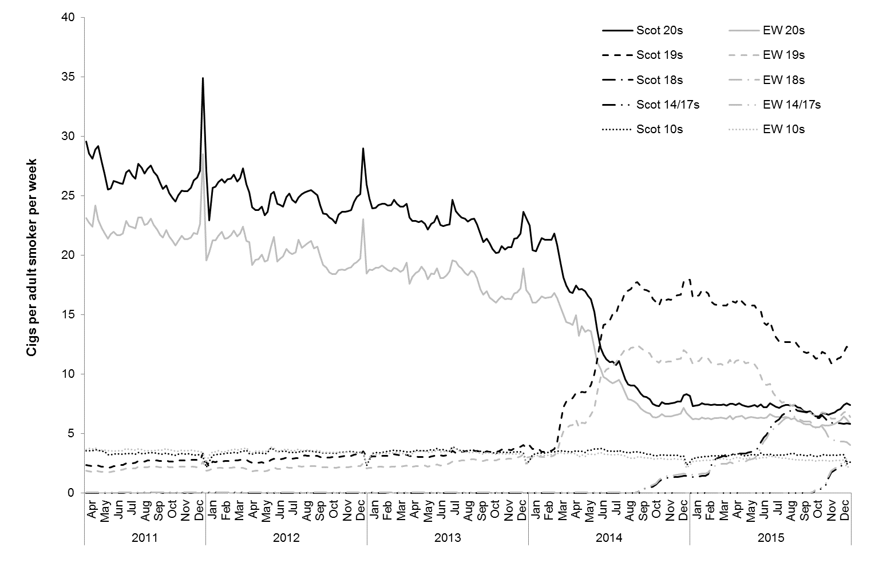
Source: Cigarette sales data were obtained from Nielsen. Notes: Scot = Scotland; EW = England/Wales

